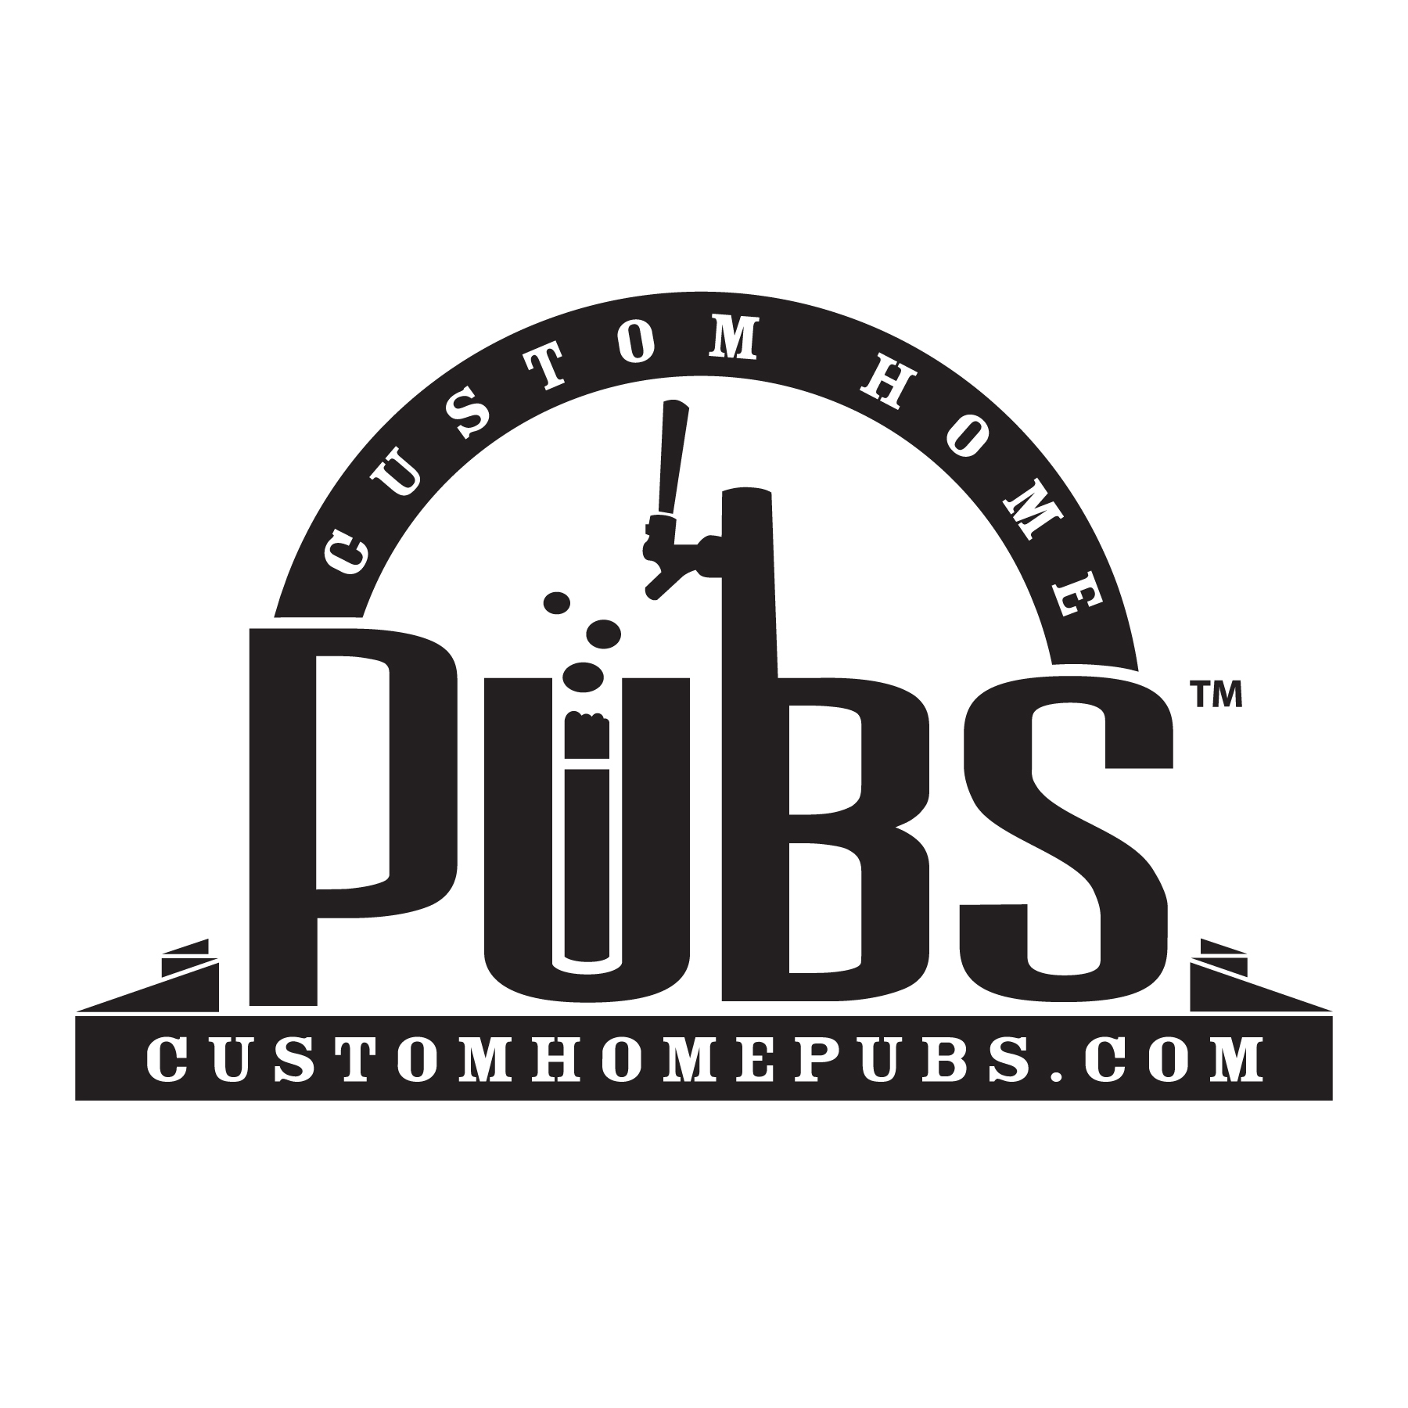
Custom Home Pubs Service Plan
For a term of 12 months, CHP Service Plan Members are entitled to the following benefits and discounts:
- Four free line cleaning (roughly every three months)
- Four free beer deliveries with line cleanings
- 50% off delivery
- Free co2 Exchanges
- $15 keg deposits (instead of $50)
- 5% off all accessories
- Expert draft technical support

Contract Start Date: ____________________
Contract End Date: ____________________
Fee: $250.00($325.00 outside Meck/Union County)
Customer Name: ____________________
Customer Signature: _____________________
Customer Address: _____________________
City/State/Zip: _____________________
Customer Phone: _____________________
Customer Email: _____________________
Date: ____________________

